

ANKARA YILDIRIM BEYAZIT UNIVERSITY

2020-2021 ACADEMIC YEAR
SPRING TERM
MIS 311

PROJECT

ESRA NUR URAL
GÜL ELÇİN AĞYÜZLÜ

Number: 18030411024 – 18030411006
Department: MIS

Instructor’s name: SAFA BURAK GÜRLEYEN

What is Cybersecurity?
Cyber security can be described as the collective methods, technologies, and processes to help protect the confidentiality, integrity, and availability of computer systems, networks and data, against cyber-attacks or unauthorized access. The main purpose of cyber security is to protect all organizational assets from both external and internal threats as well as disruptions caused due to natural disasters.
Cyber security can be divided into a few common categories:
- Network security is the practice of securing a computer network from intruders, whether targeted attackers or opportunistic malware.

- Application security focuses on keeping software and devices free of threats. A compromised application could provide access to the data its designed to protect. Successful security begins in the design stage, well before a program or device is deployed.

- Information security protects the integrity and privacy of data, both in storage and in transit.

- Operational security includes the processes and decisions for handling and protecting data assets. The permissions users have when accessing a network and the procedures that determine how and where data may be stored or shared all fall under this umbrella.

- Disaster recovery and business continuity define how an organization responds to a cyber-security incident or any other event that causes the loss of operations or data. Disaster recovery policies dictate how the organization restores its operations and information to return to the same operating capacity as before the event. Business continuity is the plan the organization falls back on while trying to operate without certain resources.

- End-user education addresses the most unpredictable cyber-security factor: people. Anyone can accidentally introduce a virus to an otherwise secure system by failing to follow good security practices. Teaching users to delete suspicious email attachments, not plug in unidentified USB drives, and various other important lessons is vital for the security of any organization.

What is a cyber-attack?
A cyber-attack is a deliberate attempt by external or internal threats or attackers to exploit and compromise the confidentiality, integrity and availability of information systems of a target organization or individual(s). Cyber-attackers use illegal methods, tools and approaches to cause damages and disruptions or gain unauthorized access to computers, devices, networks, applications and databases.
Cyber-attacks come in a wide variety and the following list highlights some of important ones that criminals and attackers use to exploit software:
- Malware
- Ransomware
- Injection attacks (e.g., cross-site scripting, SQL injection, command injection)
- Session management and Man-in-the-Middle attacks
- Phishing
- Denial of service
- Privilege escalations
- Unpatched/Vulnerable software
- Remote code execution
- Brute force

What is a Firewall?
A firewall the packet headers of network traffic, according to predefined rules, protocol type, source address, destination address, source port and or destination part according to analyzing and filtering device or application. Any packet that does not comply with the filter is rejected.

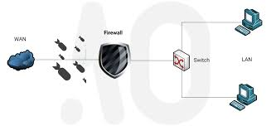

What is OPNsense?
OPNsense is a complete operating system, open source, specifically, directed for use as a router and firewall on our home or Business Network. OPNsense includes numerous completely free configuration options that only the most expensense commercial firewalls have.


OPNsense Core Features
- Traffic Shaper
- Two-Factor Authentication
- Captive portal
- Forward Caching Proxy (transparent) with Blacklist support
- Virtual Private Network (site to site & road warrior)
- High Availability & Hardware Failover
- Intrusion Detection and Prevention
- Build-in reporting and monitoring tools including RRD Graphs
- Netflow Export & Analysis
- Support for plugins
- DNS Server & DNS Forwarder
- DHCP Server and Relay
- Dynamic DNS
- Encrypted configuration backup to Google Drive
- Stateful inspection firewall
- Granular control over state table
- 802.1Q VLAN support
How OPNsense Works?
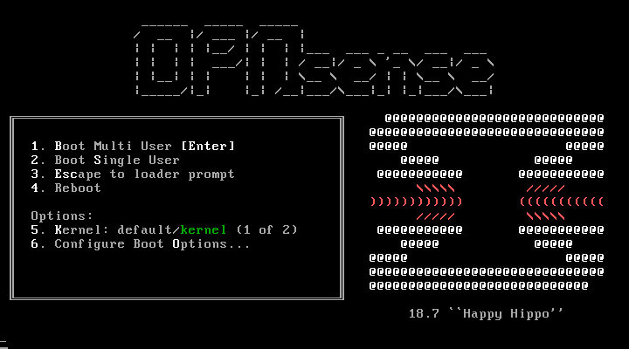

OPNsense Boot Menu
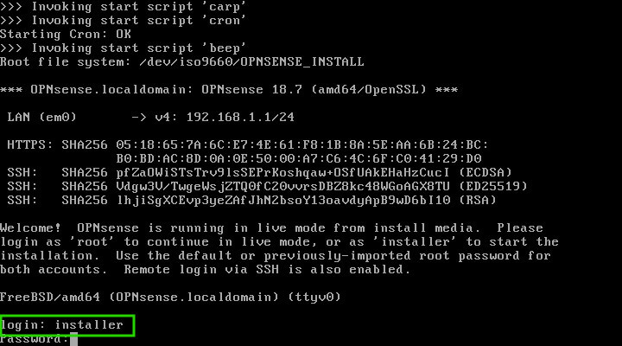

OPNsense Live Mode
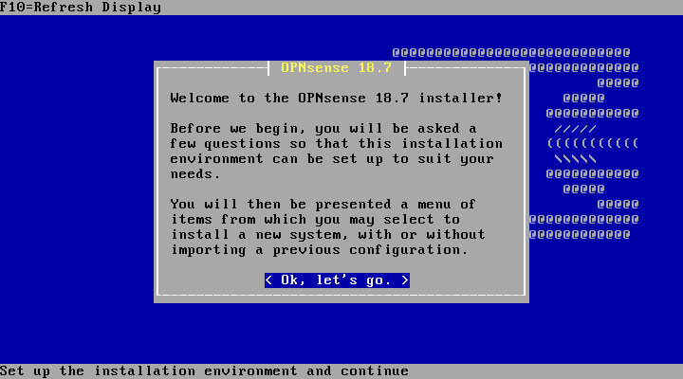

OPNsense Installer
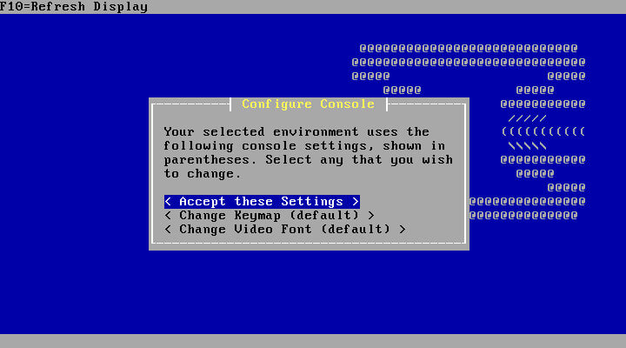

OPNsense Key Map Settings
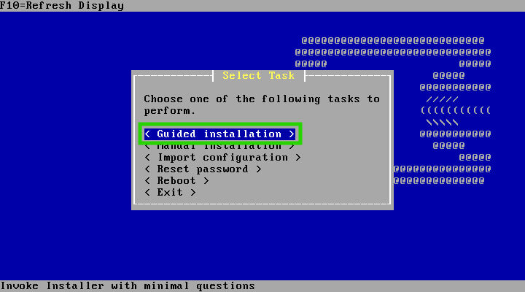

OPNsense Installation Type
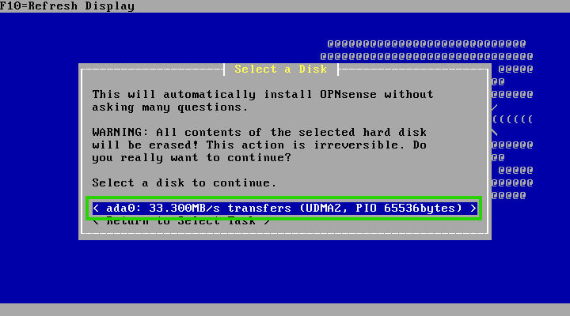

OPNsense Installation Device
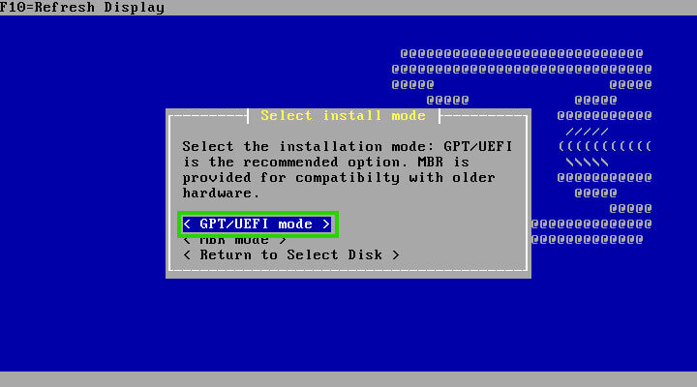

OPNsense Setup Mode
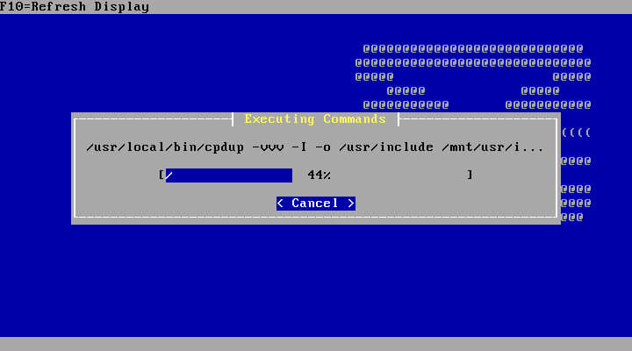

OPNsense Installation Process
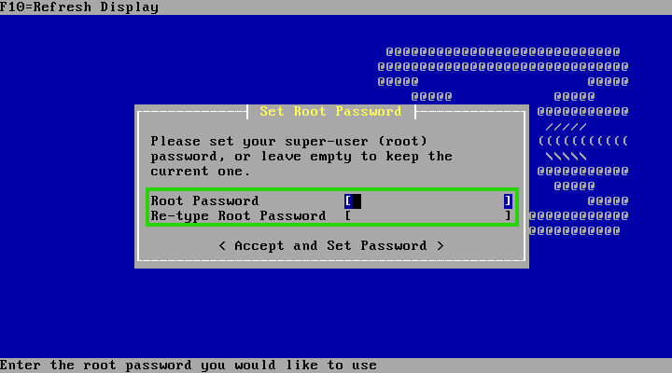

OPNsense Root Password
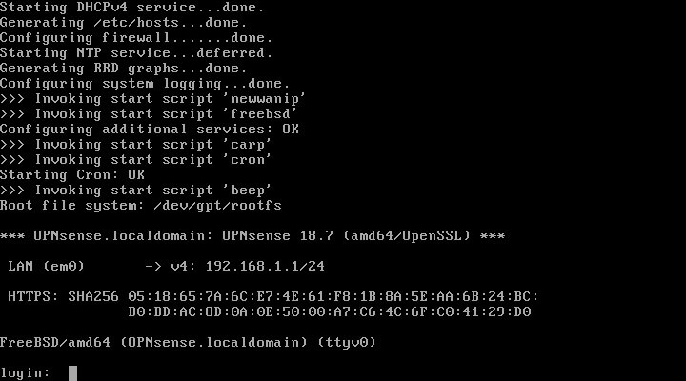

OPNsense Input Prompt
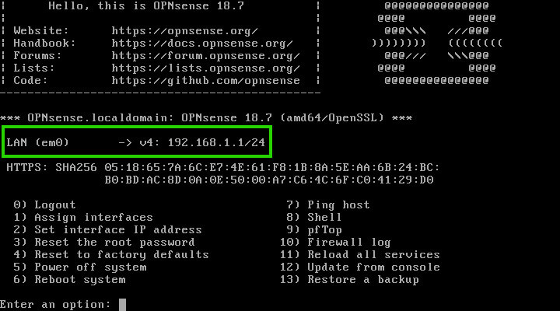

OPNsense Network Interfaces
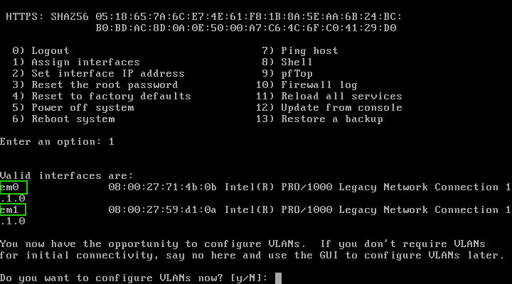

Configure the OPNsense Network Interfaces
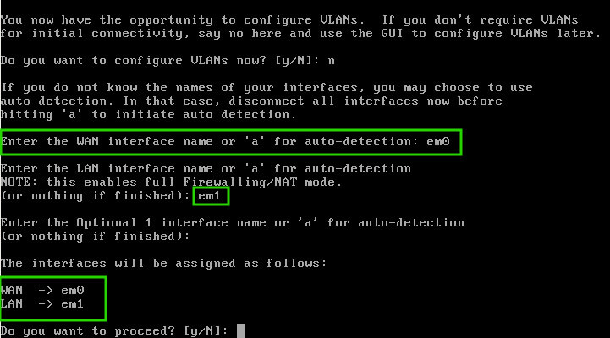

OPNsense Network Configurations
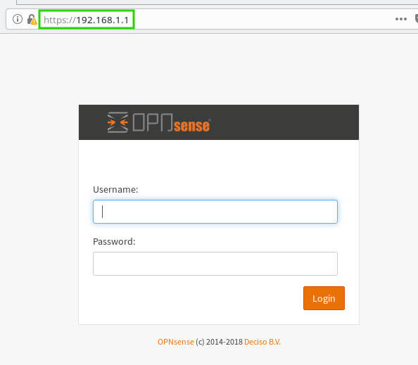
OPNsense Input Interfaces
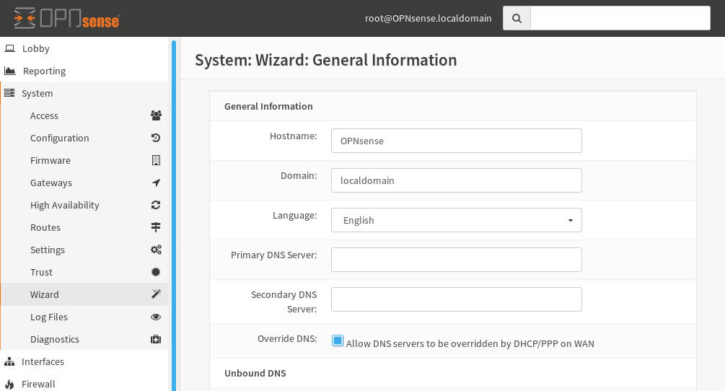

OPNsense vs. Pfsense – Which is the better option?
The search for the perfect firewall to protect and manage your home or work network is not a walk in the park because there are quite a variety of options in the market. However, Opnsense and Pfsense often come up in these searches. Pfsense was first released in 2006, its name was derived from its use of the packet filtering tool PF while Opnsense was developed from pfsense and was launched in 2015. From their relationship, it is clear that both programmes were made to address the same software network issues which were protection and control of the network, while providing additional features that increase functionality like web filters and supporting site to site VPNs and clients.
The key to choosing the best firewall is comparing it to another against your specific needs. This is because, where one fails, another redeems and vice versa which makes picking the best one a matter of professional perspective.

What are the differences between OPNsense and Pfsense?
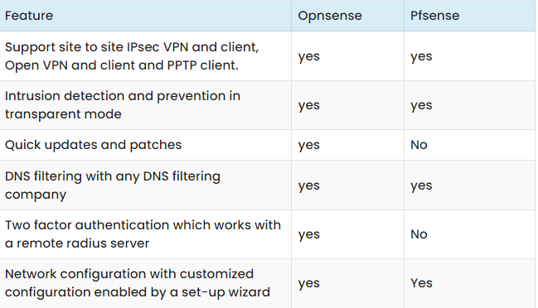

Conclusion
OPNsense have very good, constantly updated documentation, which is vital when using an open source network. OPNsense logging and limiter web proxy, and rewritten them, which makes them a bit different to use, though just as effective.The plug in framework for Opnsense has a better rewrite and offers better extensibility without having to deal with core modifications which would be essential to a web developer.

